Parenting Culture(s) Across 37 Countries

Online Supplemental Material

First, the sociodemographic characteristics of fathers and mothers in each country is presented in Table S1 and Table S2. Second, we made supplementary analysis to check the validity of our analysis. After randomly assigning each participant to one of the five groups, we replicated exactly the same SNA analysis strategy as described in the method of the current research. The results showed not only the same concepts but also a similar association between concepts (e.g., one predominant theme, i.e., loving; see Table S3) and relation of educational groups to good-parent beliefs (e.g., the concepts of "patient" and "calm" were typical of the high-educated groups whereas "family" and "children" typical of lower educated; see Figure S1).

**Table S1**

*Sociodemographic Profiles of Father Sample in Each Country*

|  |  |  |  |  |  |  |  |  |  |  |  |  |  |  |  |  |  |  |  |  |
| --- | --- | --- | --- | --- | --- | --- | --- | --- | --- | --- | --- | --- | --- | --- | --- | --- | --- | --- | --- | --- |
| Countries | Final Sample size | Age a | Educational level a | Working status (% paid profession) | Family types | | | | | | Number of biological children a | Number of children in the household a | Age of the youngest child a | Age of the oldest child a | Number of women caring for children a | Number of men caring for children a | Hours with children a | Neighborhood | | |
| % Two opposite-sex parents | % Single parent | % Step-family | % Two same-sex parents | % Multigenerational | % Polygamous | % disadvantaged | % average | % prosperous |
| Algeria | 113 | 44.81 (9.70) | 14.28 (4.97) | 93 | 74 | 2 | 0 | 0 | 25 | 0 | 2.77 (1.58) | 2.80 (1.70) | 7.57 (8.05) | 12.82 (10.45) | 1.49 (1.03) | 1.36 (0.91) | 5.91 (3.33) | 6 | 82 | 12 |
| Australia | 80 | 48.19 (11.07) | 13.28 (2.88) | 65 | 80 | 8 | 8 | 0 | 3 | 0 | 2.14 (1.10) | 1.74 (0.78) | 10.78 (7.40) | 15.54 (9.83) | 0.91 (0.36) | 0.93 (0.31) | 5.55 (3.74) | 9 | 69 | 23 |
| Austria | 15 | 40.27 (10.79) | 14.47 (4.76) | 80 | 100 | 0 | 0 | 0 | 0 | 0 | 2.00 (1.56) | 1.60 (0.74) | 4.40 (5.49) | 7.80 (11.01) | 1.13 (0.52) | 1.00 (0.38) | 5.87 (2.83) | 13 | 60 | 27 |
| Belgium | 172 | 40.20 (8.12) | 16.32 (2.56) | 97 | 87 | 5 | 6 | 1 | 1 | 0 | 2.05 (1.06) | 2.02 (1.18) | 6.84 (7.10) | 9.17 (8.20) | 1.15 (0.75) | 1.05 (0.45) | 5.14 (2.46) | 5 | 47 | 49 |
| Brazil | 81 | 45.23 (9.23) | 15.70 (5.21) | 98 | 94 | 1 | 4 | 0 | 1 | 0 | 1.65 (0.88) | 1.50 (0.75) | 11.14 (8.40) | 12.56 (8.34) | 1.14 (0.57) | 1.04 (0.44) | 3.68 (2.15) | 10 | 70 | 20 |
| Burundi | 90 | 41.31 (9.12) | 10.50 (5.75) | 79 | 91 | 9 | 0 | 0 | 0 | 0 | 3.76 (2.26) | 4.21 (2.38) | 4.85 (5.70) | 12.25 (7.82) | 1.48 (0.75) | 1.53 (1.09) | 4.36 (3.10) | 25 | 55 | 21 |
| Cameroun | 99 | 40.19 (10.39) | 14.49 (3.40) | 80 | 67 | 15 | 5 | 0 | 5 | 3 | 3.54 (2.72) | 4.02 (3.21) | 5.11 (6.79) | 14.80 (9.91) | 1.43 (0.99) | 1.26 (0.75) | 6.95 (4.39) | 23 | 72 | 5 |
| Canada | 16 | 33.25 (7.09) | 14.50 (2.48) | 94 | 75 | 13 | 13 | 0 | 0 | 0 | 2.00 (0.73) | 2.13 (0.62) | 2.87 (3.00) | 6.25 (4.06) | 1.50 (2.31) | 1.25 (1.34) | 6.06 (3.02) | 13 | 69 | 19 |
| Chile | 55 | 41.15 (9.54) | 18.64 (3.67) | 93 | 80 | 2 | 15 | 2 | 2 | 0 | 1.87 (0.92) | 1.65 (0.73) | 7.68 (10.63) | 11.11 (11.00) | 1.27 (0.71) | 1.07 (0.47) | 7.13 (6.29) | 2 | 62 | 36 |
| China | 178 | 40.24 (4.35) | 10.36 (2.52) | 97 | 82 | 4 | 4 | 0 | 10 | 0 | 1.37 (0.50) | 1.37 (0.50) | 8.75 (4.71) | 14.20 (2.76) | 1.93 (0.94) | 1.80 (0.93) | 3.20 (2.38) | 7 | 87 | 6 |
| Costa Rica | 37 | 40.57 (8.72) | 15.64 (4.91) | 89 | 81 | 3 | 3 | 0 | 11 | 0 | 1.73 (1.15) | 1.43 (0.69) | 8.47 (7.67) | 10.65 (9.50) | 1.35 (0.89) | 1.16 (0.60) | 6.51 (4.82) | 5 | 54 | 41 |
| Cuba | 102 | 40.24 (10.21) | 13.48 (3.06) | 91 | 56 | 0 | 7 | 0 | 36 | 1 | 1.78 (0.59) | 1.55 (0.54) | 8.88 (5.39) | 13.33 (9.15) | 1.64 (0.64) | 1.42 (0.62) | 9.73 (3.69) | 8 | 63 | 29 |
| Ecuador | 34 | 33.65 (6.31) | 18.41 (2.54) | 94 | 82 | 0 | 6 | 0 | 12 | 0 | 1.65 (0.81) | 1.62 (0.70) | 2.93 (2.96) | 7.03 (6.44) | 1.76 (0.78) | 1.41 (0.56) | 5.82 (3.54) | 3 | 59 | 38 |
| Egypt | 105 | 49.06 (7.11) | 12.03 (3.66) | 1 | 88 | 4 | 1 | 0 | 8 | 0 | 3.12 (1.22) | 2.89 (1.40) | 12.47 (6.35) | 20.16 (8.06) | 1.24 (0.81) | 0.73 (1.14) | 7.66 (2.36) | 30 | 55 | 15 |
| Finland | 134 | 37.77 (7.22) | 17.42 (3.99) | 91 | 82 | 2 | 14 | 0 | 1 | 0 | 2.19 (1.50) | 2.30 (1.58) | 3.45 (3.24) | 6.91 (5.05) | 1.04 (0.46) | 0.91 (0.29) | 5.89 (2.64) | 0 | 100 | 0 |
| France | 162 | 43.68 (9.30) | 15.29 (3.14) | 95 | 80 | 6 | 12 | 1 | 1 | 0 | 2.21 (0.95) | 1.81 (0.85) | 8.95 (6.64) | 13.36 (9.30) | 1.15 (1.29) | 0.98 (0.70) | 6.11 (3.29) | 3 | 52 | 46 |
| Germany | 30 | 36.60 (8.51) | 14.77 (6.17) | 80 | 73 | 7 | 13 | 0 | 7 | 0 | 1.60 (0.77) | 1.60 (0.81) | 5.62 (4.91) | 7.93 (7.02) | 1.07 (0.52) | 1.10 (0.40) | 5.30 (2.96) | 7 | 67 | 27 |
| Iran | 175 | 42.22 (9.35) | 13.57 (3.50) | 95 | 82 | 13 | 4 | 0 | 0 | 1 | 1.87 (1.11) | 1.73 (0.83) | 9.95 (7.25) | 13.74 (9.69) | 1.02 (0.36) | 1.03 (0.23) | 3.94 (2.15) | 12 | 61 | 28 |
| Italy | 94 | 47.15 (9.86) | 14.29 (3.84) | 92 | 89 | 3 | 6 | 0 | 1 | 0 | 1.71 (0.81) | 1.65 (0.80) | 12.29 (7.77) | 14.20 (9.57) | 1.11 (0.43) | 1.01 (0.31) | 4.86 (3.43) | 2 | 71 | 27 |
| Japan | 182 | 53.73 (12.53) | 15.16 (2.42) | 84 | 90 | 1 | 0 | 1 | 6 | 0 | 2.00 (0.78) | 1.63 (0.77) | 14.61 (9.82) | 21.16 (12.02) | 1.03 (0.48) | 1.10 (0.37) | 2.99 (2.09) | 2 | 80 | 19 |
| Lebanon | 61 | 40.13 (7.58) | 15.98 (3.68) | 98 | 95 | 3 | 2 | 0 | 0 | 0 | 2.34 (1.15) | 2.11 (1.00) | 7.09 (6.33) | 9.92 (8.16) | 1.25 (0.47) | 1.00 (0.00) | 5.84 (1.86) | 7 | 69 | 25 |
| Peru | 88 | 43.06 (12.54) | 13.72 (4.29) | 94 | 73 | 5 | 11 | 1 | 10 | 0 | 1.99 (0.93) | 1.97 (1.03) | 11.25 (10.27) | 15.33 (11.75) | 1.59 (0.93) | 1.41 (0.91) | 6.26 (4.30) | 8 | 68 | 24 |
| Poland | 123 | 39.80 (7.22) | 16.75 (3.89) | 98 | 87 | 2 | 4 | 0 | 7 | 0 | 1.93 (0.88) | 1.85 (0.80) | 7.31 (5.38) | 10.49 (6.38) | 1.19 (0.69) | 1.11 (0.64) | 4.49 (2.17) | 8 | 76 | 15 |
| Portugal | 151 | 44.28 (8.22) | 13.85 (4.25) | 97 | 92 | 1 | 5 | 0 | 1 | 0 | 1.71 (0.87) | 1.58 (0.59) | 10.61 (6.99) | 12.81 (8.24) | 0.98 (0.36) | 0.90 (0.44) | 4.30 (2.09) | 1 | 65 | 34 |
| Romania | 114 | 39.29 (6.20) | 16.10 (3.12) | 99 | 95 | 2 | 2 | 0 | 2 | 0 | 1.51 (0.71) | 1.54 (0.64) | 5.58 (4.54) | 8.34 (5.22) | 1.47 (0.69) | 1.18 (0.63) | 4.57 (2.30) | 5 | 36 | 59 |
| Russia | 88 | 35.94 (6.86) | 14.61 (3.66) | 98 | 84 | 0 | 11 | 0 | 5 | 0 | 1.69 (0.90) | 1.72 (0.88) | 4.15 (3.92) | 7.78 (6.36) | 1.28 (0.71) | 1.08 (0.35) | 3.98 (2.11) | 1 | 56 | 43 |
| Serbia | 35 | 39.17 (6.65) | 14.63 (5.22) | 94 | 94 | 3 | 0 | 0 | 0 | 0 | 1.63 (0.49) | 1.66 (0.54) | 4.94 (4.85) | 7.51 (5.53) | 0.94 (0.64) | 1.09 (0.51) | 5.57 (2.37) | 6 | 60 | 34 |
| Spain | 126 | 42.40 (7.76) | 15.48 (3.03) | 94 | 94 | 2 | 3 | 0 | 0 | 0 | 1.70 (0.64) | 1.66 (0.60) | 8.33 (6.72) | 9.93 (8.29) | 1.63 (0.87) | 1.40 (0.72) | 5.02 (3.46) | 10 | 74 | 17 |
| Switzerland | 92 | 40.25 (7.62) | 16.29 (3.90) | 99 | 85 | 4 | 10 | 1 | 0 | 0 | 1.95 (0.95) | 1.93 (0.84) | 5.42 (6.59) | 8.68 (7.16) | 1.13 (0.50) | 0.99 (0.35) | 6.42 (4.06) | 0 | 55 | 45 |
| Thailand | 90 | 43.70 (6.08) | 3.36 (1.11) | 99 | 67 | 0 | 2 | 0 | 30 | 0 | 1.81 (0.60) | 1.83 (0.71) | 8.93 (3.95) | 12.73 (4.63) | 1.89 (1.02) | 1.56 (0.91) | 5.30 (3.70) | 0 | 53 | 47 |
| The Netherlands | 34 | 41.50 (10.21) | 15.94 (2.09) | 97 | 94 | 3 | 3 | 0 | 0 | 0 | 2.03 (1.00) | 1.80 (0.94) | 9.59 (8.09) | 8.76 (8.64) | 1.32 (0.84) | 1.26 (0.79) | 4.35 (1.56) | 3 | 59 | 38 |
| Togo | 44 | 38.34 (8.45) | 13.79 (2.88) | 86 | 71 | 18 | 0 | 0 | 2 | 9 | 2.64 (2.00) | 2.91 (1.87) | 3.19 (3.81) | 9.57 (8.30) | 1.11 (0.39) | 1.23 (0.71) | 7.88 (5.00) | 23 | 70 | 7 |
| Turkey | 144 | 37.41 (6.42) | 14.01 (3.09) | 75 | 86 | 7 | 1 | 0 | 6 | 0 | 1.67 (0.74) | 1.60 (0.63) | 4.55 (3.67) | 7.42 (5.83) | 1.15 (0.47) | 0.97 (0.36) | 7.03 (4.06) | 4 | 71 | 26 |
| The UK | 86 | 42.26 (9.39) | 14.37 (3.09) | 94 | 90 | 6 | 4 | 0 | 1 | 0 | 1.97 (0.99) | 1.76 (0.72) | 9.66 (7.23) | 13.27 (8.70) | 0.99 (0.19) | 0.98 (0.26) | 4.62 (2.42) | 5 | 62 | 34 |
| Uruguay | 104 | 36.45 (7.28) | 12.02 (4.77) | 94 | 84 | 0 | 8 | 0 | 7 | 0 | 1.64 (0.77) | 1.66 (0.76) | 2.68 (1.71) | 6.19 (5.72) | 1.29 (0.66) | 1.11 (0.42) | 10.19 (4.76) | 2 | 77 | 21 |
| The USA | 111 | 41.55 (10.16) | 14.55 (3.19) | 87 | 76 | 13 | 5 | 0 | 5 | 1 | 1.93 (1.11) | 1.86 (1.04) | 7.22 (6.48) | 11.45 (8.22) | 1.01 (0.95) | 0.96 (0.74) | 6.79 (5.52) | 14 | 62 | 24 |
| Vietnam | 72 | 38.31 (9.13) | 14.13 (3.85) | 97 | 78 | 0 | 0 | 1 | 19 | 0 | 1.61 (0.80) | 1.48 (0.61) | 7.51 (5.41) | 9.22 (9.10) | 1.54 (0.72) | 1.34 (0.75) | 3.71 (2.44) | 6 | 58 | 36 |
| Pooled sample | 3,517 | 41.96 (9.63) | 14.23 (4.40) | 89 | 83 | 4 | 5 | 0 | 6 | 0 | 2.02 (1.23) | 1.94 (1.27) | 7.78 (7.08) | 11.95 (9.04) | 1.28 (0.79) | 1.15 (0.67) | 5.48 (3.67) | 7 | 66 | 27 |

**Table S2**

*Sociodemographic Profiles of Mother Sample in Each Country*

|  |  |  |  |  |  |  |  |  |  |  |  |  |  |  |  |  |  |  |  |  |
| --- | --- | --- | --- | --- | --- | --- | --- | --- | --- | --- | --- | --- | --- | --- | --- | --- | --- | --- | --- | --- |
| Countries | Final Sample size | Age a | Educational level a | Working status (% paid profession) | Family types | | | | | | Number of biological children a | Number of children in the household a | Age of the youngest child a | Age of the oldest child a | Number of women caring for children a | Number of men caring for children a | Hours with children a | Neighborhood | | |
| % Two opposite-sex parents | % Single parent | % Step-family | % Two same-sex parents | % Multigenerational | % Polygamous | % disadvantaged | % average | % prosperous |
| Algeria | 159 | 39.10 (10.35) | 13.92 (4.97) | 56 | 64 | 2 | 0 | 0 | 35 | 0 | 2.47 (1.51) | 2.45 (1.41) | 7.75 (7.67) | 12.07 (10.41) | 1.69 (1.12) | 1.48 (1.05) | 10.32 (6.62) | 4 | 83 | 13 |
| Australia | 85 | 41.61 (8.41) | 12.80 (2.86) | 49 | 61 | 25 | 9 | 0 | 4 | 0 | 2.06 (0.99) | 1.86 (1.00) | 8.61 (7.33) | 12.88 (7.47) | 1.06 (0.56) | 0.86 (0.64) | 7.45 (3.93) | 6 | 78 | 17 |
| Austria | 134 | 33.10 (5.79) | 12.99 (2.86) | 72 | 87 | 6 | 3 | 1 | 4 | 0 | 1.56 (0.85) | 1.56 (0.84) | 2.45 (4.08) | 4.23 (5.07) | 1.10 (0.37) | 0.99 (0.40) | 10.93 (4.81) | 2 | 72 | 27 |
| Belgium | 1078 | 37.83 (7.13) | 16.48 (2.56) | 91 | 79 | 11 | 8 | 1 | 0 | 0 | 2.09 (0.97) | 2.11 (0.95) | 5.71 (5.67) | 8.79 (6.95) | 1.21 (0.66) | 0.99 (0.55) | 5.65 (3.23) | 3 | 48 | 49 |
| Brazil | 128 | 41.82 (8.19) | 16.28 (3.81) | 70 | 89 | 3 | 5 | 0 | 1 | 0 | 1.55 (0.75) | 1.51 (0.70) | 8.88 (7.40) | 11.08 (7.96) | 1.20 (0.51) | 1.02 (0.46) | 6.54 (5.06) | 15 | 68 | 17 |
| Burundi | 87 | 36.79 (9.37) | 10.86 (4.86) | 56 | 84 | 16 | 0 | 0 | 0 | 0 | 3.55 (1.81) | 3.64 (2.11) | 5.16 (5.15) | 13.00 (8.14) | 1.69 (1.21) | 1.28 (0.98) | 7.15 (4.59) | 24 | 51 | 25 |
| Cameroun | 97 | 36.81 (8.68) | 14.06 (3.02) | 69 | 74 | 18 | 2 | 0 | 5 | 0 | 2.69 (1.55) | 3.52 (2.67) | 5.51 (6.54) | 13.74 (8.92) | 1.65 (1.23) | 1.05 (0.91) | 9.93 (5.52) | 20 | 71 | 9 |
| Canada | 196 | 34.40 (6.72) | 15.92 (2.67) | 83 | 84 | 7 | 8 | 0 | 1 | 0 | 2.15 (0.87) | 2.15 (0.85) | 3.88 (4.51) | 7.33 (6.22) | 1.07 (0.45) | 0.99 (0.39) | 9.26 (6.70) | 8 | 62 | 30 |
| Chile | 327 | 35.80 (5.63) | 17.69 (3.31) | 74 | 71 | 13 | 7 | 0 | 8 | 0 | 1.72 (0.88) | 1.83 (1.45) | 4.22 (4.54) | 7.90 (6.52) | 1.57 (0.82) | 0.98 (0.59) | 11.14 (7.51) | 2 | 60 | 38 |
| China | 211 | 37.91 (4.03) | 10.78 (2.52) | 91 | 79 | 6 | 2 | 1 | 12 | 0 | 1.32 (0.47) | 1.34 (0.52) | 8.25 (4.69) | 14.08 (3.43) | 1.83 (0.80) | 1.60 (0.79) | 4.09 (2.40) | 4 | 92 | 4 |
| Costa Rica | 121 | 36.17 (6.77) | 17.13 (4.18) | 81 | 72 | 10 | 6 | 0 | 8 | 0 | 1.53 (0.75) | 1.48 (0.68) | 7.34 (7.11) | 8.30 (7.67) | 1.55 (0.84) | 1.06 (0.66) | 10.80 (6.29) | 4 | 65 | 31 |
| Cuba | 137 | 40.06 (10.36) | 13.84 (3.12) | 78 | 47 | 12 | 15 | 0 | 23 | 0 | 1.63 (0.62) | 1.47 (0.61) | 11.59 (8.47) | 14.82 (9.50) | 1.68 (0.80) | 1.15 (0.74) | 11.77 (4.67) | 11 | 60 | 29 |
| Ecuador | 78 | 31.95 (6.81) | 16.58 (2.73) | 83 | 59 | 18 | 6 | 0 | 15 | 1 | 1.63 (0.70) | 1.64 (0.68) | 5.31 (4.34) | 8.35 (6.57) | 2.06 (1.09) | 1.38 (0.94) | 8.40 (5.40) | 1 | 74 | 24 |
| Egypt | 109 | 46.75 (5.54) | 10.95 (3.41) | 2 | 74 | 18 | 0 | 1 | 6 | 0 | 3.51 (1.49) | 3.07 (1.39) | 14.63 (6.42) | 25.03 (5.30) | 1.36 (1.03) | 1.23 (1.07) | 9.04 (4.02) | 6 | 69 | 25 |
| Finland | 1366 | 36.28 (6.40) | 17.69 (3.29) | 75 | 78 | 10 | 10 | 0 | 0 | 0 | 2.16 (1.14) | 2.25 (1.27) | 4.43 (4.29) | 7.59 (5.30) | 0.91 (0.37) | 0.87 (0.44) | 7.90 (3.75) | 0 | 100 | 0 |
| France | 589 | 37.07 (7.42) | 15.06 (2.58) | 82 | 76 | 13 | 9 | 1 | 1 | 0 | 1.90 (0.86) | 1.85 (0.83) | 5.91 (5.33) | 8.78 (6.75) | 1.42 (1.08) | 0.98 (0.67) | 8.65 (5.25) | 3 | 58 | 39 |
| Germany | 93 | 35.41 (7.72) | 13.59 (4.34) | 69 | 72 | 17 | 7 | 0 | 2 | 0 | 1.88 (1.21) | 1.77 (1.00) | 4.89 (4.93) | 8.14 (7.18) | 1.02 (0.47) | 0.84 (0.54) | 8.38 (4.05) | 5 | 76 | 18 |
| Iran | 179 | 38.21 (7.97) | 13.55 (3.15) | 40 | 85 | 11 | 3 | 0 | 1 | 0 | 1.87 (0.94) | 1.67 (0.70) | 10.55 (7.94) | 14.12 (9.35) | 1.13 (0.47) | 0.98 (0.40) | 7.56 (3.56) | 12 | 56 | 33 |
| Italy | 218 | 42.14 (8.34) | 15.26 (3.70) | 84 | 85 | 6 | 5 | 0 | 3 | 0 | 1.81 (0.71) | 1.78 (0.70) | 8.50 (6.86) | 11.94 (8.68) | 1.15 (0.57) | 1.02 (0.43) | 8.33 (5.54) | 2 | 77 | 21 |
| Japan | 148 | 53.33 (15.71) | 13.77 (2.02) | 43 | 71 | 16 | 1 | 0 | 5 | 0 | 1.96 (0.77) | 1.54 (0.75) | 13.60 (11.58) | 23.65 (15.81) | 1.14 (0.42) | 0.76 (0.53) | 6.34 (5.01) | 1 | 85 | 14 |
| Lebanon | 117 | 36.74 (8.30) | 16.56 (3.48) | 55 | 94 | 4 | 1 | 0 | 1 | 0 | 2.26 (1.06) | 2.18 (0.99) | 7.99 (6.32) | 10.67 (7.83) | 1.26 (0.52) | 1.01 (0.36) | 7.86 (2.85) | 3 | 70 | 27 |
| Peru | 174 | 39.34 (9.81) | 14.89 (5.00) | 81 | 61 | 20 | 6 | 0 | 12 | 0 | 1.94 (0.87) | 1.99 (1.13) | 8.40 (7.45) | 12.92 (8.82) | 2.05 (1.25) | 1.41 (1.20) | 9.49 (5.87) | 7 | 66 | 27 |
| Poland | 294 | 33.00 (5.32) | 17.87 (3.32) | 67 | 87 | 6 | 3 | 0 | 5 | 0 | 1.66 (1.00) | 1.65 (0.88) | 3.54 (4.13) | 4.98 (4.78) | 1.19 (0.72) | 0.96 (0.61) | 9.45 (4.98) | 3 | 77 | 19 |
| Portugal | 163 | 39.43 (7.37) | 15.73 (3.00) | 90 | 88 | 3 | 7 | 0 | 3 | 0 | 1.76 (0.86) | 1.77 (0.78) | 5.78 (5.26) | 9.00 (7.49) | 1.04 (0.51) | 0.89 (0.37) | 5.48 (3.29) | 1 | 62 | 36 |
| Romania | 168 | 35.95 (5.11) | 17.35 (2.53) | 85 | 89 | 4 | 3 | 0 | 4 | 0 | 1.56 (0.62) | 1.54 (0.61) | 3.41 (3.76) | 6.34 (5.16) | 1.43 (0.74) | 1.09 (0.65) | 9.43 (7.54) | 2 | 23 | 76 |
| Russia | 214 | 33.66 (6.47) | 14.38 (4.30) | 79 | 74 | 9 | 9 | 0 | 6 | 0 | 1.67 (0.79) | 1.69 (0.80) | 4.03 (3.93) | 8.05 (6.24) | 1.28 (0.67) | 1.02 (0.61) | 9.26 (5.52) | 1 | 61 | 39 |
| Serbia | 107 | 37.52 (5.20) | 14.84 (5.04) | 90 | 95 | 2 | 0 | 0 | 2 | 0 | 1.64 (0.68) | 1.65 (0.69) | 4.01 (4.22) | 6.63 (5.25) | 1.25 (0.70) | 1.06 (0.56) | 8.43 (5.12) | 2 | 46 | 52 |
| Spain | 295 | 40.86 (8.12) | 15.39 (4.11) | 83 | 80 | 9 | 6 | 0 | 3 | 0 | 1.74 (0.75) | 1.73 (0.74) | 8.42 (7.57) | 9.84 (8.54) | 1.44 (1.05) | 1.14 (0.68) | 9.42 (6.46) | 5 | 84 | 11 |
| Switzerland | 185 | 39.28 (6.40) | 15.98 (3.07) | 87 | 80 | 12 | 8 | 1 | 0 | 0 | 2.00 (0.83) | 2.05 (0.87) | 6.29 (4.95) | 8.78 (5.80) | 1.14 (0.62) | 0.96 (0.48) | 7.34 (4.77) | 0 | 48 | 52 |
| Thailand | 115 | 42.63 (5.60) | 3.26 (1.05) | 97 | 71 | 4 | 1 | 1 | 23 | 0 | 1.75 (0.63) | 1.80 (0.74) | 8.97 (3.74) | 12.90 (4.74) | 1.83 (1.03) | 1.48 (0.81) | 6.24 (3.95) | 0 | 50 | 50 |
| The Netherlands | 102 | 36.10 (6.93) | 16.97 (2.30) | 95 | 90 | 4 | 3 | 1 | 0 | 0 | 1.75 (0.71) | 1.68 (0.72) | 4.48 (4.87) | 5.51 (6.11) | 1.50 (0.99) | 1.06 (0.50) | 7.09 (3.09) | 4 | 50 | 46 |
| Togo | 25 | 38.92 (10.67) | 12.96 (2.51) | 92 | 76 | 16 | 4 | 0 | 0 | 4 | 2.40 (1.29) | 3.12 (1.76) | 7.51 (7.83) | 15.84 (9.88) | 1.52 (0.59) | 0.84 (0.37) | 11.16 (6.93) | 16 | 80 | 4 |
| Turkey | 239 | 35.95 (5.91) | 13.68 (3.61) | 78 | 87 | 6 | 0 | 0 | 5 | 0 | 1.65 (0.62) | 1.63 (0.60) | 4.18 (2.85) | 7.31 (5.35) | 1.14 (0.49) | 1.04 (0.39) | 6.27 (3.01) | 6 | 74 | 20 |
| The UK | 117 | 37.31 (7.01) | 15.75 (2.94) | 78 | 88 | 9 | 3 | 0 | 0 | 0 | 1.91 (0.89) | 1.80 (0.72) | 4.92 (5.33) | 6.99 (6.07) | 1.03 (0.21) | 0.95 (0.52) | 8.03 (4.43) | 6 | 48 | 46 |
| Uruguay | 173 | 34.10 (5.91) | 13.08 (4.65) | 87 | 73 | 16 | 4 | 0 | 4 | 0 | 1.57 (0.75) | 1.55 (0.73) | 2.84 (1.71) | 6.10 (4.85) | 1.49 (0.80) | 1.03 (0.60) | 12.54 (5.42) | 3 | 72 | 25 |
| The USA | 241 | 36.88 (8.58) | 15.48 (3.36) | 71 | 68 | 20 | 7 | 0 | 4 | 0 | 2.02 (1.09) | 1.96 (1.04) | 5.83 (5.39) | 10.56 (7.36) | 1.15 (0.72) | 0.88 (0.74) | 8.09 (5.10) | 8 | 74 | 18 |
| Vietnam | 88 | 35.61 (6.57) | 13.84 (4.24) | 94 | 79 | 4 | 0 | 1 | 15 | 0 | 1.58 (0.66) | 1.65 (1.22) | 5.00 (4.72) | 8.08 (6.51) | 1.42 (0.95) | 1.16 (0.75) | 5.24 (3.75) | 4 | 44 | 52 |
| Pooled sample | 8,357 | 37.56 (8.02) | 15.45 (4.05) | 77 | 78 | 10 | 6 | 0 | 4 | 0 | 1.94 (1.02) | 1.95 (1.10) | 5.90 (5.96) | 9.45 (7.83) | 1.28 (0.79) | 1.02 (0.64) | 8.08 (5.14) | 4 | 69 | 27 |

**Table S3**

*The Themes and the Three Most Frequently-Occurring Concepts of Good-Mother/Father Beliefs Across Across the Random Groups*

|  |  |  |  |  |  |  |  |  |  |  |  |  |  |  |  |  |  |
| --- | --- | --- | --- | --- | --- | --- | --- | --- | --- | --- | --- | --- | --- | --- | --- | --- | --- |
| **Random Group 1** | | | |  | **Random Group 2** | | | | | | |  | **Random Group 3** | | | | |
| Good-Mother (*N* = 1655) | | Good-Father  (*N* = 726) | |  | Good-Mother  (*N* = 1601) | | | Good-Father (*N* = 744) | | | |  | Good-Mother (*N* = 1670) | | | Good-Father (*N* = 678) | |
| Themes | # | Themes | # |  | Themes | # | | Themes | | # | |  | Themes | | # | Themes | # |
| loving | 1536 | loving | 633 |  | loving | 1480 | | loving | | 647 | |  | loving | | 1492 | loving | 573 |
| sense | 488 | affectionate | 249 |  | empathic | 495 | | strong | | 159 | |  | empathic | | 631 | affectionate | 223 |
| family | 174 | strict | 52 |  | available | 278 | | children | | 113 | |  | family | | 321 | family | 83 |
| Concepts | # | Concepts | # |  | Concepts | # | | Concepts | | # | |  | Concepts | | # | Concepts | # |
| loving | 680 | loving | 280 |  | loving | 672 | | loving | | 252 | |  | loving | | 689 | loving | 235 |
| patient | 449 | responsible | 181 |  | patient | 452 | | responsible | | 176 | |  | patient | | 481 | responsible | 163 |
| responsible | 385 | patient | 152 |  | responsible | 347 | | patient | | 160 | |  | responsible | | 357 | patient | 129 |
| **Random Group 4** | | | |  | **Random Group 5** | | | | | | | | |
| Good-Mother (*N* = 1715) | | Good-Father (*N* = 681) | |  | Good-Mother (*N* = 1716) | | | | Good-Father (*N* = 688) | | | | |
| Themes | # | Themes | # |  | Themes | | # | | Themes | | # | | |
| loving | 1560 | loving | 572 |  | loving | | 1596 | | loving | | 611 | | |
| empathic | 625 | family | 256 |  | humor | | 395 | | family | | 113 | | |
| family | 252 | widsom | 20 |  | family | | 300 | | strict | | 17 | | |
| Concepts | # | Concepts | # |  | Concepts | | # | | Concepts | | # | | |
| loving | 712 | loving | 261 |  | loving | | 699 | | loving | | 232 | | |
| patient | 466 | responsible | 143 |  | patient | | 498 | | responsible | | 164 | | |
| responsible | 370 | patient | 132 |  | responsible | | 385 | | patient | | 134 | | |

*Note.*# represents hits (i.e., the number of texts associated with the theme) of the themes or the frequency count (i.e., the total number of occurrences) of the concepts.

**Figure S1**

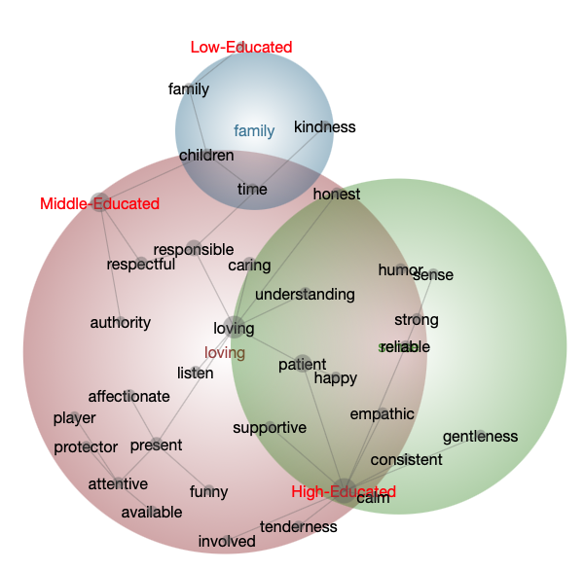*The Semantic Network Maps of the Good-Parent Beliefs and the Educational Groups in the Five Random Groups*

a. Random Group 1

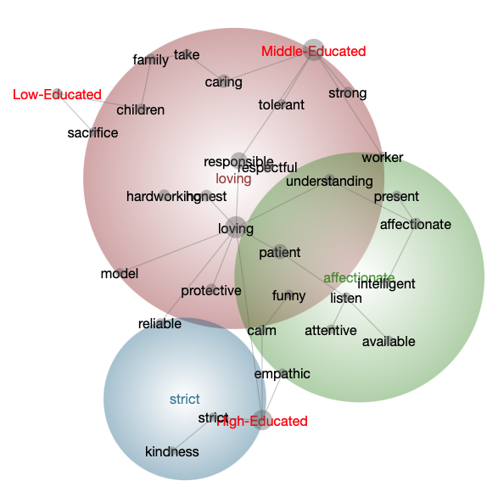

Mothers

Fathers

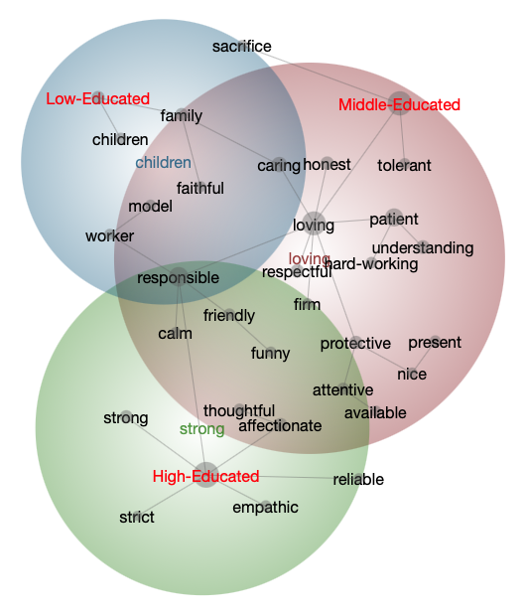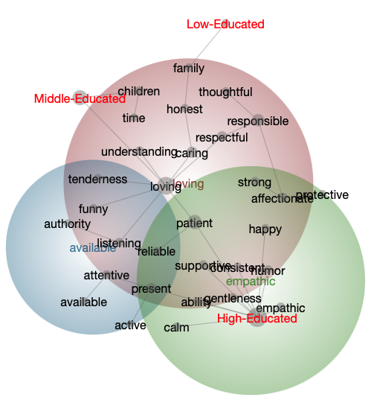

b. Random Group 2

Mothers

Fathers

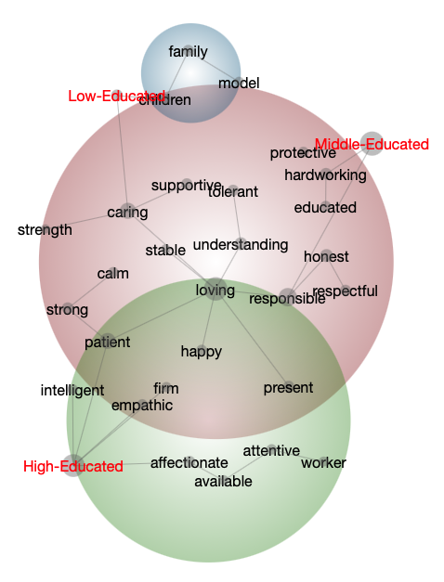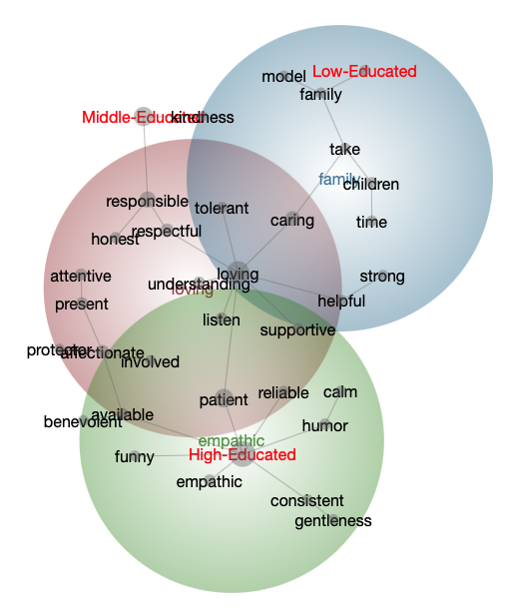

c. Random Group 3

Fathers

Mothers

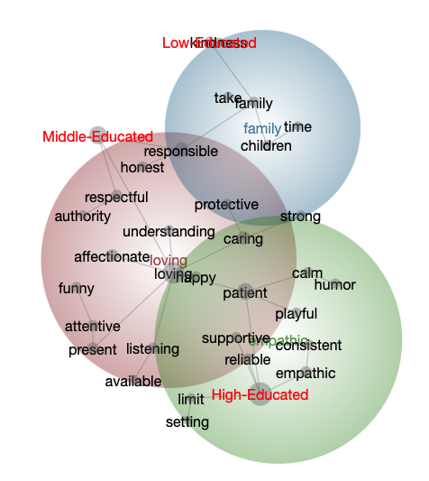

d. Random Group 4

Mothers

Fathers

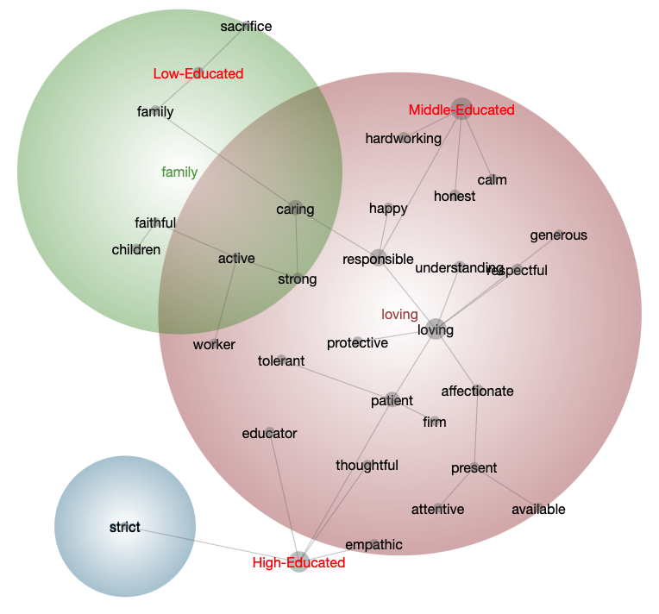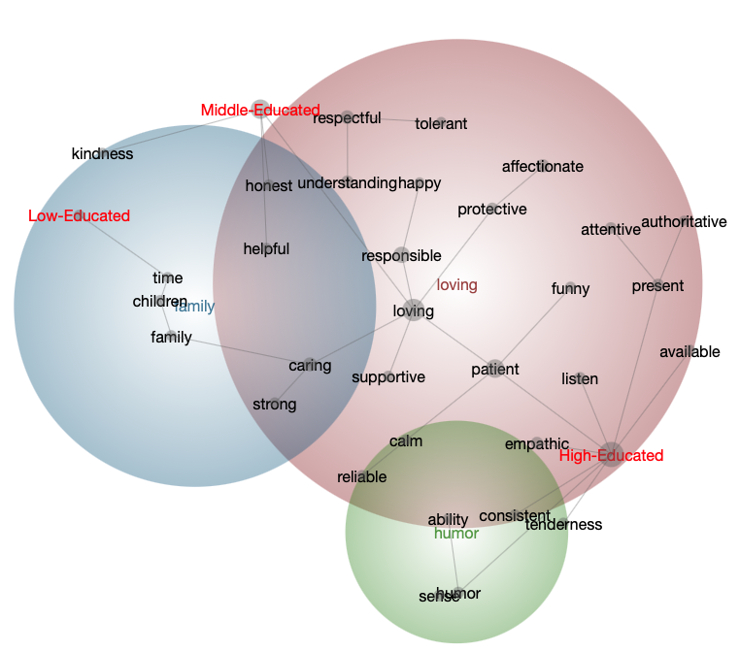

e. Random Group 5

Mothers

Fathers